Dear Parents,
Fantuan has made a major upgrade to our refund system. Going forward, you will be able to conveniently cancel your own orders by yourself, without needing to contact customer service.
Here is an example: a parent placed multiple hot lunch day orders for Amy. When the parent clicks Order and enters the backend, the system will display the orders separated by each individual hot lunch day, as shown in the example below.

1:Click the red dot in the top-left corner of the page.


2: Click on your order.
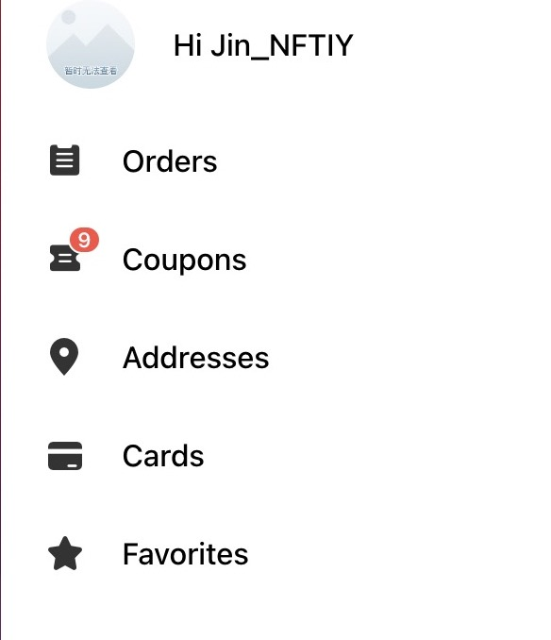

3: Find the order you want to refund. Make sure to double-check the hot lunch day, the child’s name, and the division (Div) to avoid selecting the wrong child or date.

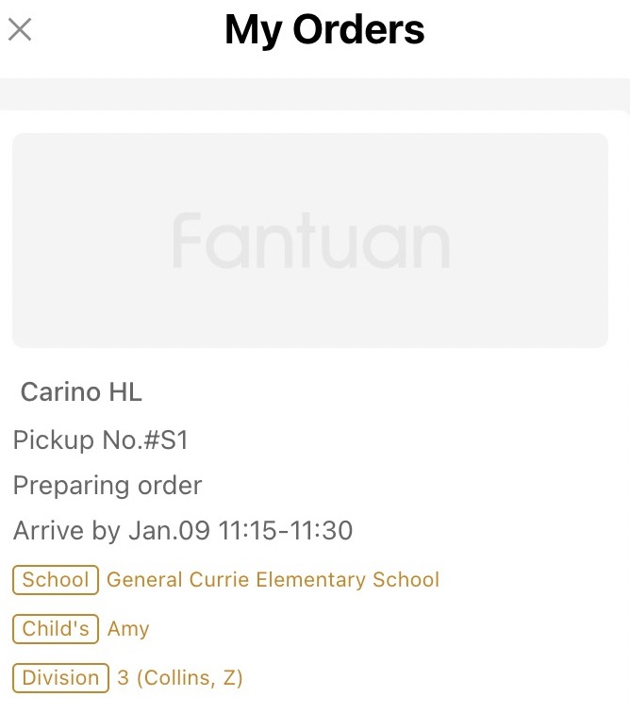

4:Click on this order, and you will be able to see the Cancel button.

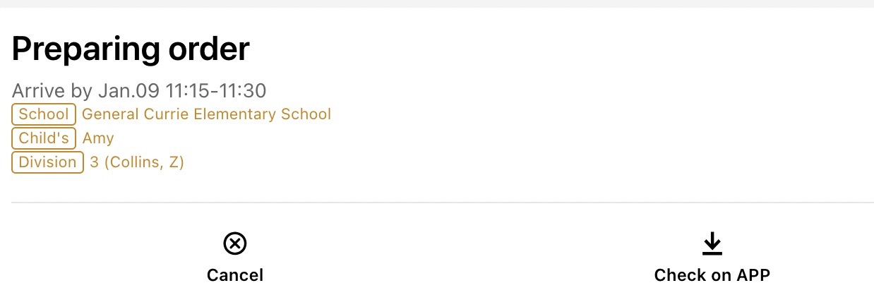

5:You can select any reason to cancel, and the refund will be automatically returned to your original payment method.

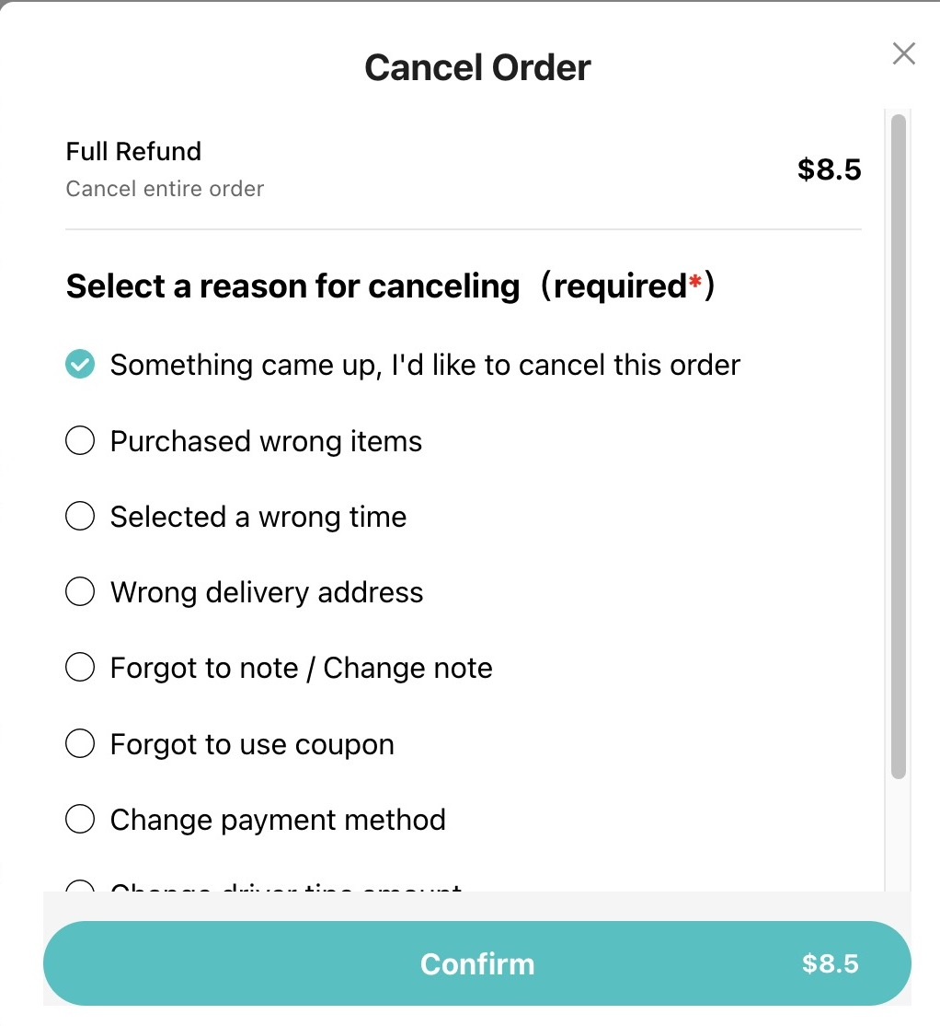

6:At this point, the system status will change to Canceled.
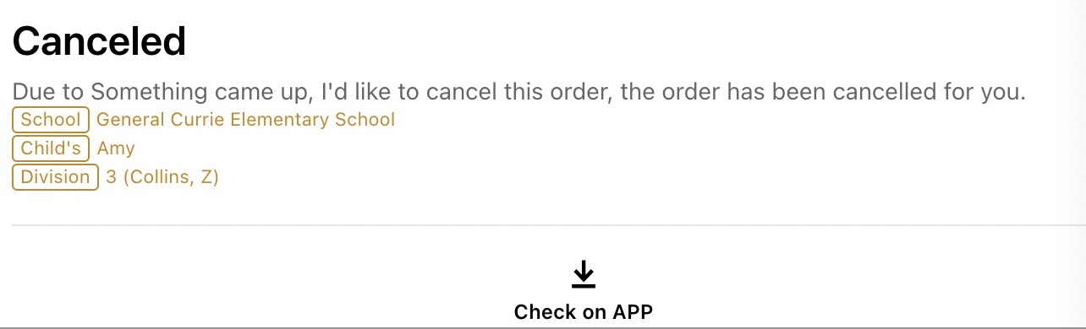

Important Reminder:
If your order has passed the cutoff day—for example, January 7 is a hot lunch day and the school’s cutoff day is 7 days earlier—then if you need a refund on January 5 due to your child being sick, please click into the order, find the payment information, and call our 24/7 toll-free customer service.778-402-2900
Please note: refunds are available up to 48 hours before the delivery time. Once it is within 48 hours of delivery, refunds will no longer be possible.

We apologize for the inconvenience. After the cutoff day, the order has already been sent to the restaurant, so the cancellation must be handled manually by our customer service team.

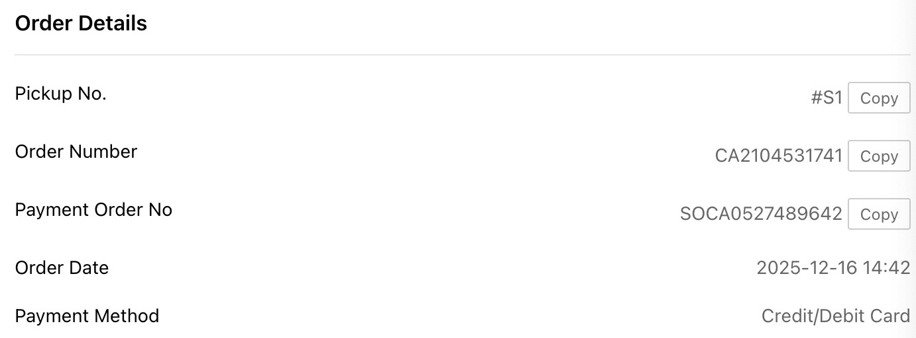

After the refund is completed, you will receive a system notification text message. This indicates that the process is complete.

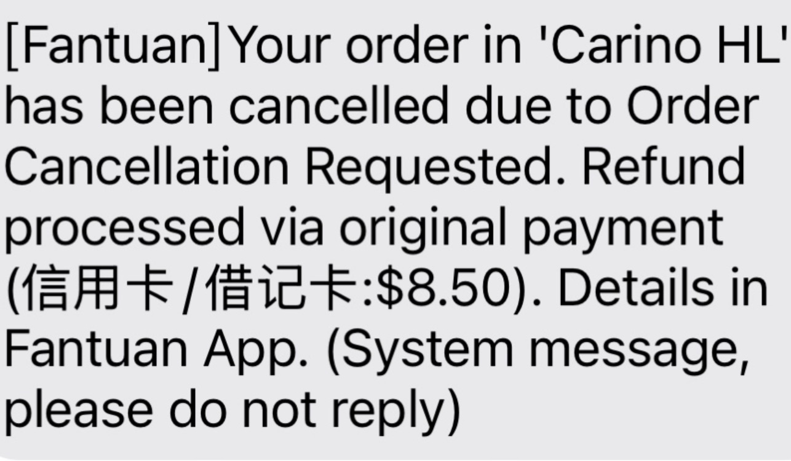

Please note: only refunds will have a confirmation text message. If you cancel the order yourself in the system, there will be no confirmation text message.

Thank you very much. We look forward to our new refund system bringing you greater flexibility and convenience when ordering hot lunches.

