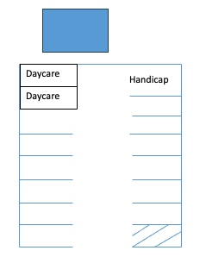

Steves Parking Lot Flow

Staff Parking Only

FOURTH AVE

Drive Through

Drop

Off Zone

Parent Parking

Staff Parking Only

S

P

R

I

N

G

F

O

R

D

A

V

E

Daycare